|  |
| --- |
| **CURRICULUM VITAE** |

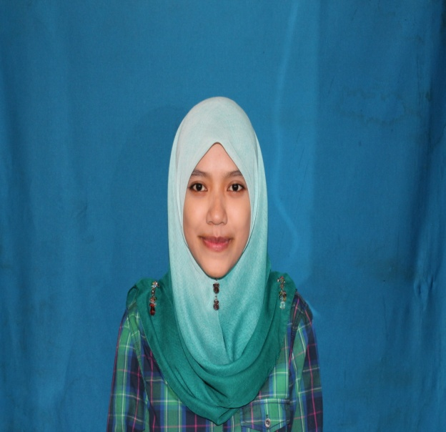

**ANISAH BINTI SAMDIN**

|  |
| --- |
| **Contact Details**  Address : 5853 Lorong Toman, Batu 3 ½ Jalan Paya Ikan, 75150 Bukit Baru, Melaka.  Mobile No. : +6012 - 3063905  Emergency No. : +6017 - 2125608  Email : [anisahsamdin@gmail.com](mailto:anisahsamdin@gmail.com) |
| **Personal Particulars**  Age : 23 years  Date of Birth : 7 April 1991  Nationality : Malaysia  Gender : Female  Marital Status : Single  IC No. : 910407-04-5108  Driving License : B2  Religion : Islam  Language : Malay/English |
| **Qualification**  Field of Study : Polymer Composite  Institute/University : Kolej Kemahiran Tinggi Mara Masjid Tanah, Melaka.  Grade : Diploma In Polymer Composite Processing Technology  Graduation Date : June 2012  **Courses Attended**   * Vacuum Bagging Process * Resin Transfer Moulding (RTM) machine * Filament Winding * Composite Repair (Aircraft Repair Follow Manual) * Basic Electric (Motor Control) * Hydraulic and Pneumatic * Hot and Cold Press Machine   **Major Course**   * Matrix and Reinforcing Fibres * Composite Processing Technology I & II * Testing and Inspection of Composites * Composite Tooling Design & Fabrication * Composite Fabrication and Assembly * Composite Repair Technique * Mechanics of Laminated Composites |
| **Experiences**  **Employment History**  **Company Name : MFS TECHNOLOGY SDN BHD, Batu Berendam, Melaka.**  Position Title : Lab Assistant (QA)  Duration : July 2013 – Present  Work Description :   * To perform chemical analysis at all chemical line such as Etching, Black Holes, Bond Film and etc * Carry out daily report after do all analysis at production line * Monitor and carry out all chemical line every 2 hours * To prepare safety daily reports and replenishment chemical report accordingly * Ensure all chemical tank have a full chemical in a spec limit * Monitor and observe all production line in corrective unsafe act and unsafe condition * Conduct safety induction in chemical laboratory * Ensure all the workers comply with Work Instruction and SOP * Assist chemist in replenishment PGC gold at line Hard Gold, Soft Gold and ENIG * Carry out a SPC Chart to maintain a control limit of chemical for line Tin Copper, Copper PAD,   Copper Panel and Waste Water   * Ensure a pH and Copper of Waste Water in a spec limit * Check content of acid (H2SO4), stripping (NaOH), gold (Au content), nickel and etc * Packing sample of chemical for every month to be send to vendor Atotech and Mac Dermid   **Company Name : CTRM AERO COMPOSITE SDN BHD, Batu Berendam, Melaka.**  Position Title : Quality Inspector (QC)  Duration : July 2012 – June 2013  Work Description :   * Measuring whether existing product meet a set quality standards, planning how often material   will be performed, determining the standard by which quality will be judge and establishing how  product and processes will be improved to meet quality standard   * Preparation of quality daily report * Conduct quality induction for workers * Observe hazards at department and conduct safety alert * Ensure all worker use a complete PPE (Personal Protective Equipment) * Ensure all material that have been utilized properly and restore at proper place after use * Ensure all worker do 5’S activity that make 15 minutes for housekeeping before every break * Mutually helping each other to solve a problem   **Company Name : SPIRIT AEROSYSTEM (M) Sdn Bhd, Subang, Selangor.**  Position Title : Technician trainee  Duration : Jan 2012 – June 2012  Reason for leaving : Internship  Work Description :   * To do a assembly part of underwing and overwing panel for Airbus A320 and A321 * Do a work step by step follow SOP (Standard Operation Procedure) * Ensure panel complete shipment and pass target for every week * Conduct daily, weekly and monthly shipment and report * Ensure all panel pass QC and maintain in a good condition * Review the work performance and provide necessary reports if have any troubleshoot * Comply with all directions given by the supervisors and team leader * Mix chemical such as Sealant PR 1782 C2 to close the small holes * Touch-up panel using a paint CA 8351 topcoat and AVIOX 38A * Drill composite panel from carbon fiber using a drilling and pilot drill * Install a component such as rod assy, clamp block and link assy correctly and neatly * Install a seal and p-seal at underwing panel * Work carefully to ensure the safety and quality for customers * Ensure that all component are installed on the panel were tied * Ensure panel and paperwork complete before send to Spirit United Kingdom (UK) |
| **Other Skills**    COMPUTING :Microsoft Office |
| **Text Resume / Additional Info**  - Creative, independent, self-motivated individuals  - Dedication and drive as a hard-working individual  - Responsible, hardworking, honest as well as self – motivated and fast learner  - Goal-oriented individual with leadership abilities and good teamwork  - Willing and passion for continuous learning and personal growth  **Activities**  - College Tournament agency and external relation curricular Jabatan Pertahanan Awam (JPAM)  - Active in sports; archery and pingpong.  **Miscellaneous**    Availability Date : 1 week  Expected Salary : RM 1900.00 negotiable  **Job Preferences**  Willing to Travel : Yes  Willing to Relocate : Yes  Availability : Immediately  Point of Mobilization : Melaka |
| **References**  Name : Mrs. Zarina Binti Rapek  Position : Chemist  Company : MFS Technology Sdn Bhd  Address : Lot 5, Phase III, Batu Berendam Free Trade Zone, 75300 Melaka.  Tel : 06-2810058  Name : Mrs. Faraliza Binti Mustapha  Position : Head of Quality Unit  Company : CTRM Aero Composite Sdn Bhd  Address : Locked Bag 1028, 75150 Batu Berendam, Melaka.  Tel : 06-2810058    Name : Mr. Mohd Radzi Bin Hanapi  Position : Supervisor  Company : Spirit Aerosystem (M) Sdn Bhd  Address : Lapangan Terbang Sultan Abdul Aziz Shah, 47200 Subang, Selangor.  Tel : 03-78463532 |